Places Speak of Genocide – Kurds Bring Them to Life
Exhibition · Installation · 2025 · Kurdistan, Germany
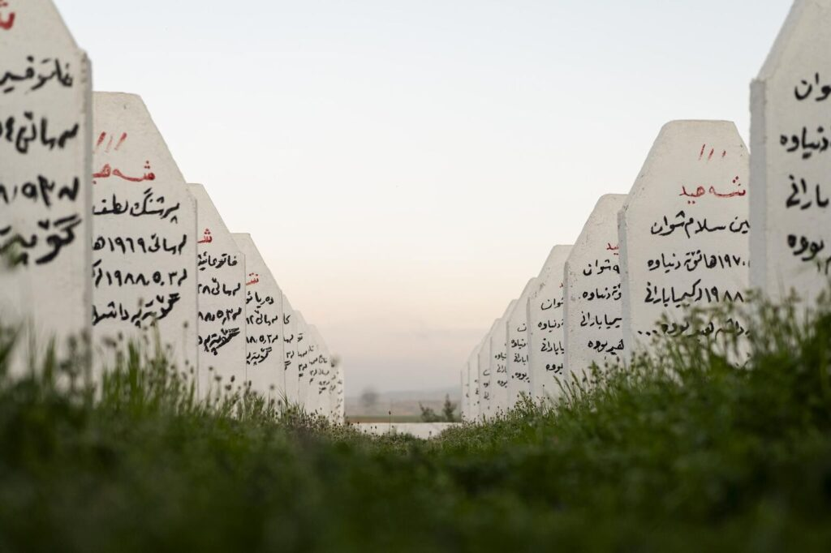
Places_Speak_of_Genocide_Kurds_Bring_Them_to_Life_hesam_yousefi

Introduction
The exhibition ""Places Speak of Genocide – Kurds Bring Them to Life"" is a hybrid presentation combining a video installation and a photo exhibition. It tells the story of a generation in Southern Kurdistan (northern Iraq) that lost its most cherished memories through war and the genocide of the Anfal campaign. At the heart of the video installation are three survivors who recount their experiences in recorded interviews—memories and events that changed their lives forever. These recordings are displayed on three separate monitors. Rengin Abdullah, Razaw Gule Mahmoud and Abdulrahman Ahmed each chose locations that hold special meaning for them as the settings in which they share their stories. These are places where they have enough space and time to reflect on their past and speak about the defining moments of their lives. The three survivors are not merely narrators—they are also directors of their own stories. They decide on the location, the camera angle, and the timing of the recordings themselves. In a calm and protected environment, they take the time they need to tell their stories. The artists' role is simply to provide the space and activate the camera. The video installation is accompanied by a photo exhibition that makes the traces of genocide visible: a destroyed village that remains abandoned to this day; a cemetery where many victims of the Anfal campaign are buried; and the remnants of tanks and weapons used during the operation. The Anfal campaign was one of the most brutal crimes in recent history. 1988, it was carried out by the Iraqi Baath regime under Saddam Hussein and led by Ali Hassan al-Majid, infamously known as ""Chemical Ali."" The aim of the campaign was the complete dismantling of Kurdish resistance, the systematic destruction of Kurdish villages, and ethnic cleansing through displacement and genocide. Over eight phases, the regime deployed airstrikes, chemical weapons, mass arrests, and public executions. An estimated 182,000 people were killed, and around 90% of Kurdish villages were destroyed.

Key facts
Work | Exhibition, Installation
Year | 2025
Country / region | Kurdistan, Germany
Camera | Lumix
Lenses | 35 mm
Film / sensor | Digital full frame
Colour | Colour

Installation views
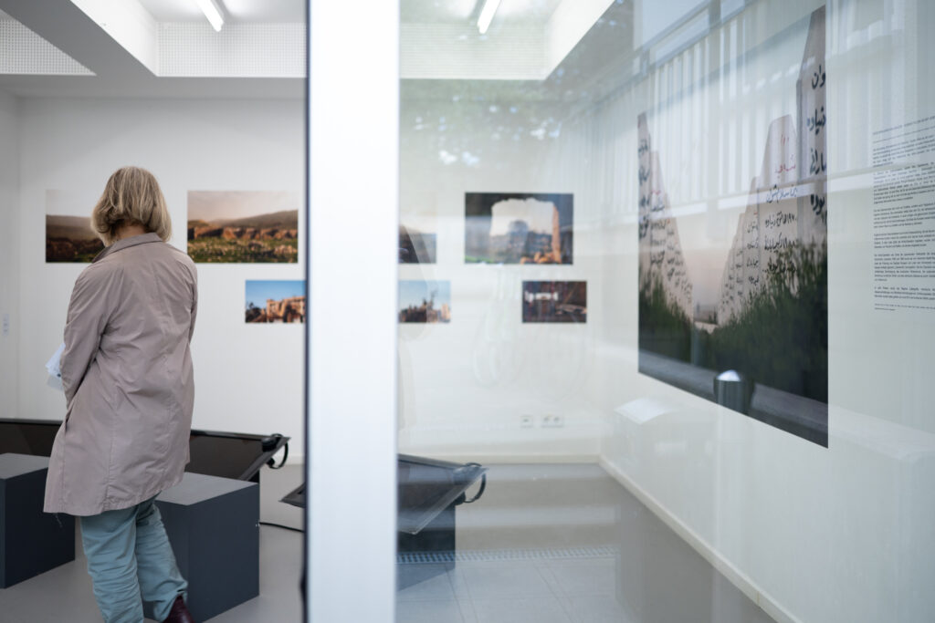
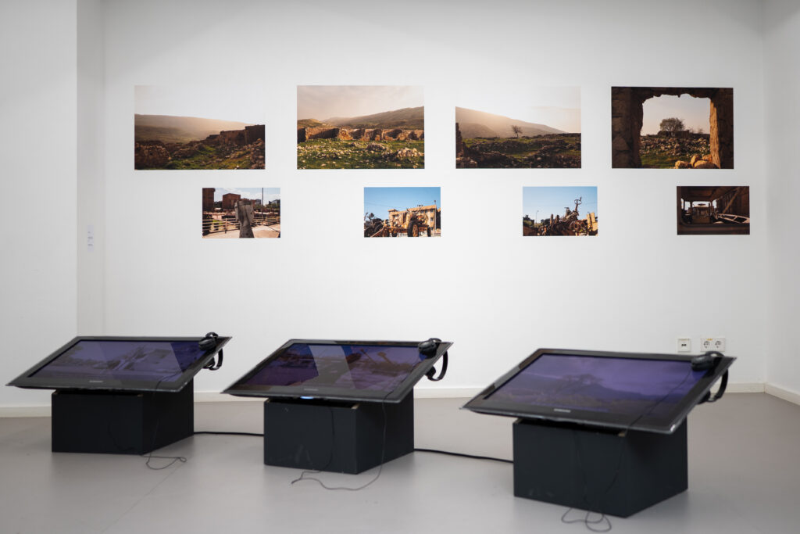
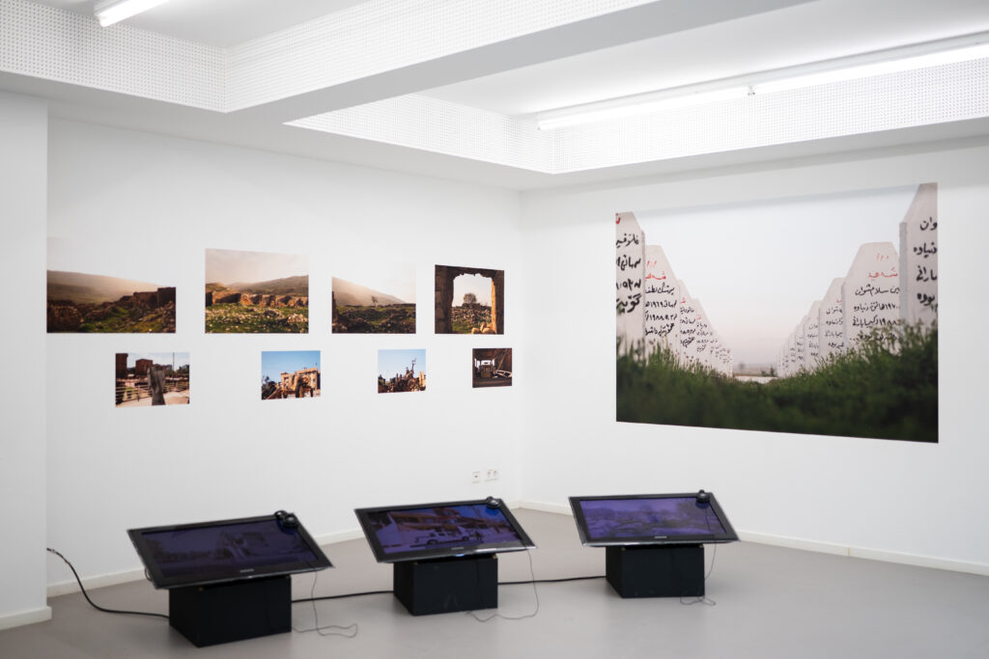
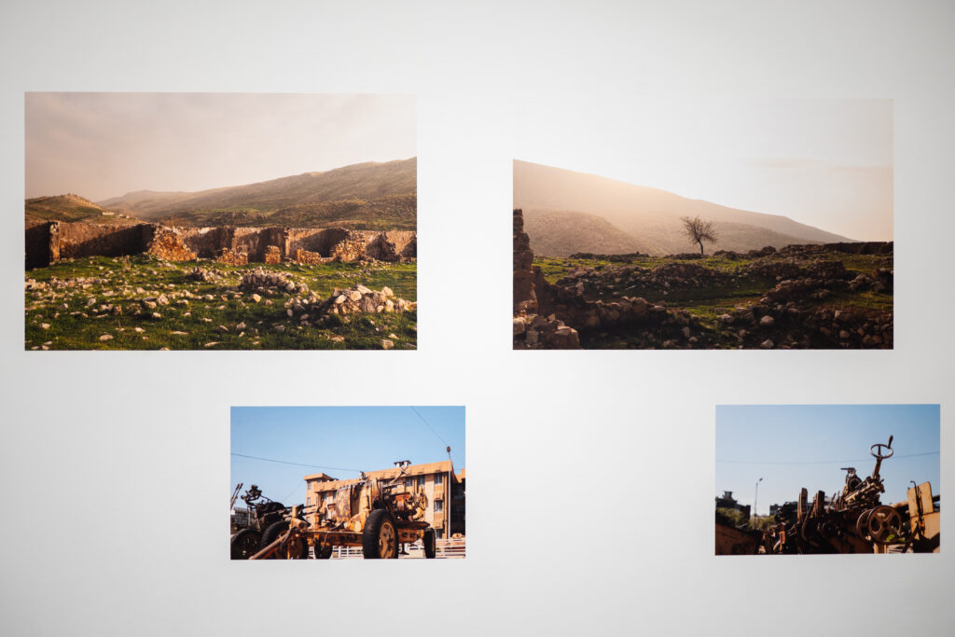
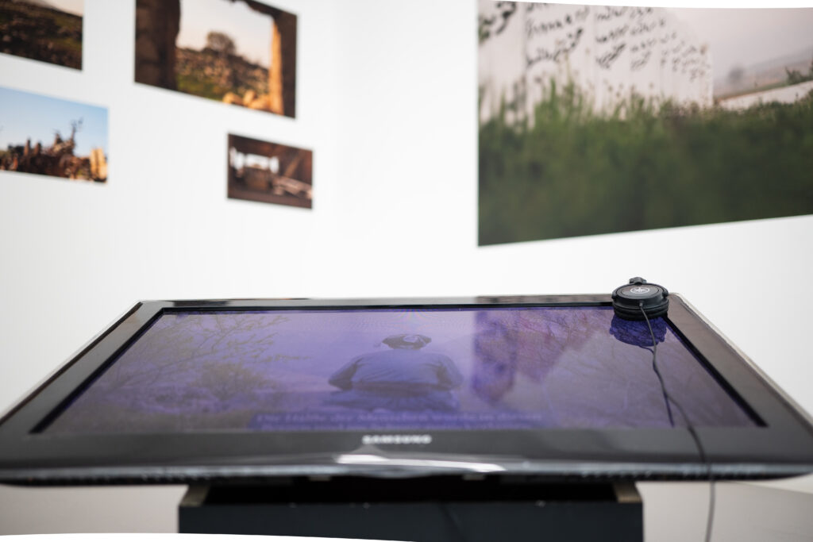

Credits
Concept | Hesam Yousefi
Cinematography | Hesam Yousefi

https://hesamyousefi.com/photography/places-speak-of-genocide-kurds-bring-them-to-life-2/

