Mina – The Price of Freedom

Mina _The_Price_of_Freedom_hesam_yousefi

Key facts
Format | Documentary
Status | Completed
Original title | Mina – The Price of Freedom
Year | 2022
Running time | 70 min
Production countries / regions | Germany
Original languages | Persian, Kurdish, German
Subtitles | German, English
Shooting format | Digital
Screening format | DCP, MP4 (H.264)
Resolution | 2K
Aspect ratio | 2.39:1 (Scope)
Colour | Colour
Sound | Stereo

Synopsis
The documentary „Mina – The Price of Freedom“ by Hesam Yousefi is a portrait of Mina Ahadi, an Iranian human rights activist who now lives in Cologne. Mina has been fighting against executions and stonings in Iran for decades – and thus became a target of the regime herself. With numerous campaigns, she has drawn the world’s attention to the cruel execution practice and thereby prevented, as just one example, the stoning of Sakineh Mohamdi-Ashtiani. The fact that stoning is no longer practiced in Iran today is, above all, due to Mina’s efforts.
A sad but key event of her life was the Iranian revolution in 1979 and the subsequent compulsory wearing of the hijab. Shortly after the Islamic Republic came to power, Mina’s husband, Ismail Yeganehdust, was executed. Mina decided to dedicate her life to the fight against the death penalty. She was able to save many people – but still far too few in her eyes. Through her campaigns and close contact with those sentenced to death, emotional bonds were formed in many instances; they called her „Mother.“ And „Mother Mina“ had to cry for many children.
In „Mina – The Price of Freedom,“ Mina Ahadi shares insights into her eventful life between family happiness and personal security. She recounts her successes and failures in the fight against the death penalty and for the rights of women, homosexuals and ex-Muslims. She received numerous death threats following the founding of the „Central Council of Ex-Muslims“. Though she has had to live in constant fear, Mina powerfully conveys that hope lives on, regardless of the cruelty.

Film stills
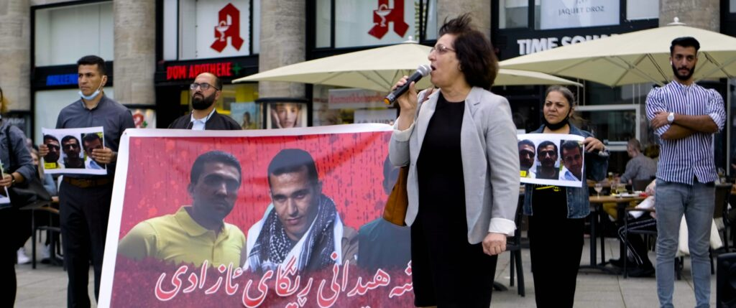
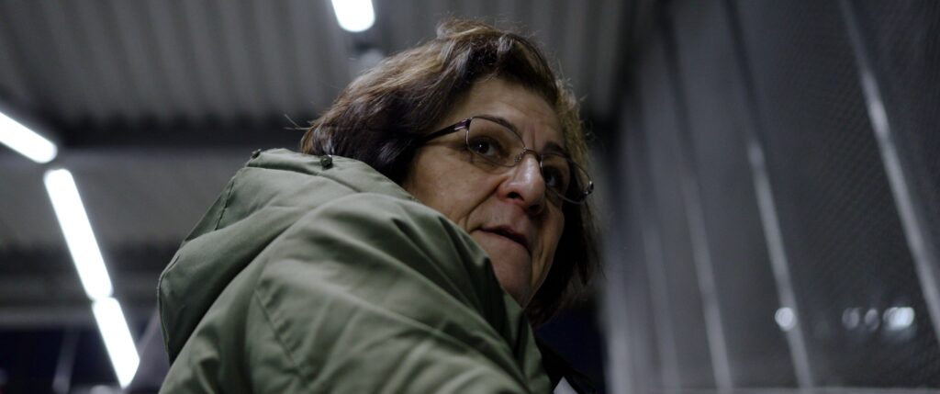
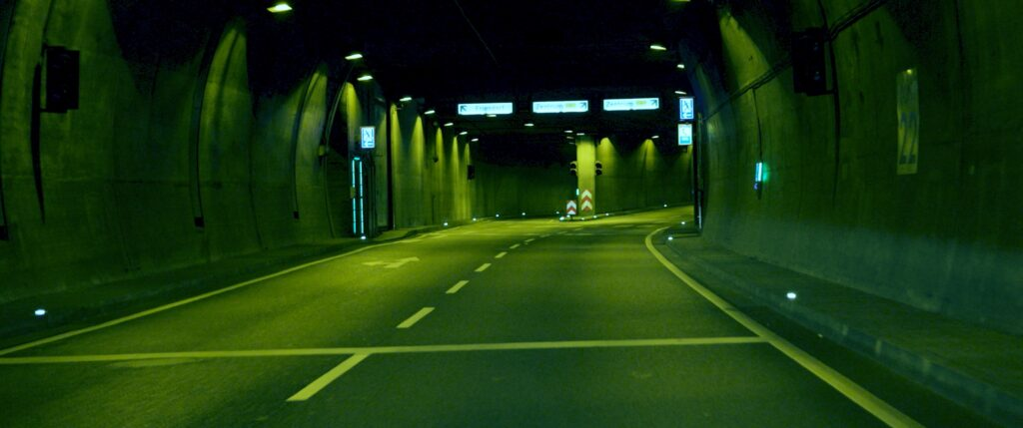

Production & Funding
Funded by | Giordano-Bruno-Stiftung

Credits
Director | Hesam Yousefi
Cinematography | Hesam Yousefi
Editing | Hesam Yousefi
Producer | Hesam Yousefi

https://hesamyousefi.com/films/mina-the-price-of-freedom/

