Shirin and Nikan
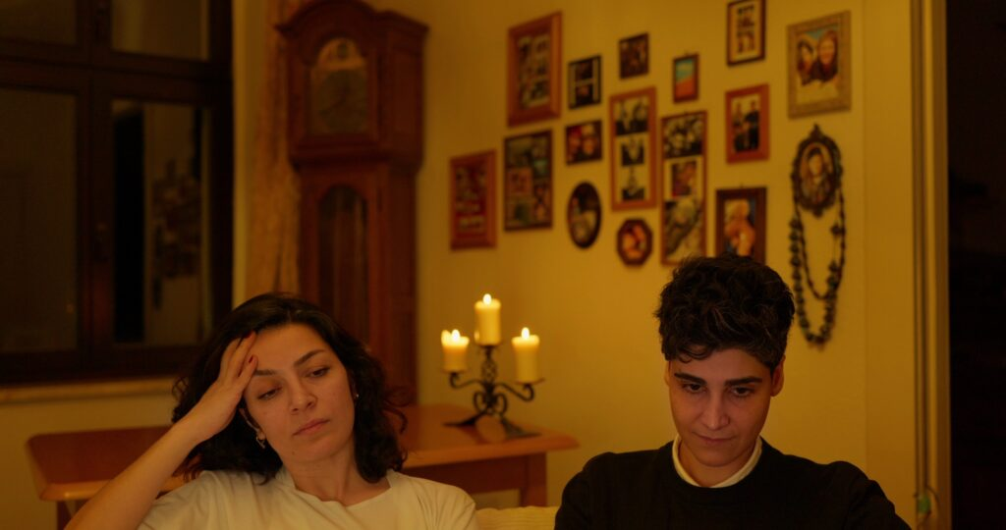

Key facts
Format | Documentary, Short film
Status | Completed
Original title | Shirin and Nikan
Year | 2026
Running time | 18 min
Production countries / regions | Germany
Filming locations | Germany
Original languages | Kurdish, Persian
Subtitles | German, English
Shooting format | Digital
Screening format | DCP, ProRes, MP4 (H.264)
Resolution | 4K DCI
Aspect ratio | 1.78:1 (16:9)
Colour | Colour
Sound | Stereo, 5.1

Synopsis
A Kurdish woman. A Persian woman. A love relationship that cannot be told in a shared language. Shirin and Nikan is a documentary film about love, intimacy, and the power of language. Shirin, politically active and shaped by oppression, abuse, and colonial violence, finds herself in a relationship that brings her both closeness and pain. Nikan, calm and apolitical, was born in Tehran and speaks Persian — a language that, for Shirin, has become the language of oppression.
The film shows how even the most personal things — a kiss, a word, a glance — are permeated by history and power relations. Between their bodies stands an invisible wall made of language. For Shirin, Persian is the language of control, police, and humiliation. And yet it is the language of the woman she loves.
Through quiet, intimate scenes, the film tells of closeness and distance, of a love that is not free from power — and of a way of speaking that not only connects but also retraumatizes and pulls them apart.

Director’s statement
The documentary Shirin and Nikan begins for me with a central question: How does colonial violence shape the most intimate relationships between people? As a Kurdish filmmaker raised under the Iranian regime—where our language was banned, our identity suppressed, and our bodies controlled—I know the kind of invisibility that such violence leaves behind.
In this film, I wanted to reveal how political power structures infiltrate even the smallest gestures: a touch, a conversation, a silence. The Kurdish language has been criminalized for decades—so what does it mean when a love between two women becomes vulnerable precisely at this fault line, when one woman’s mother tongue is also the other’s language of oppression?
My challenge was to translate this invisible violence into images within a love story. I searched for moments that do not illustrate, but allow the audience to feel how history and power can stand between two bodies.
Shirin and Nikan portrays two women who, despite language prohibitions, trauma, and social pressure, attempt to find closeness. It is also my own question to cinema: How can intimacy be shown when colonial structures constantly permeate it? The film seeks to make these power relations visible—while preserving the tenderness that persists in spite of them.

Film stills




Production & Funding
Production | Academy of Media Arts Cologne, Hesam Yousefi

Credits
Protagonist | Shirin Qureichi, Nikan Bagheri
Concept | Hesam Yousefi
Director | Hesam Yousefi
Cinematography | Hesam Yousefi
Sound designer | Sara Tavakoli
Color grading | Ewald Hentze
Editing | Hesam Yousefi
Consulting editor | Christian Becker
Supervision | Prof. Oliver Schwabe

https://hesamyousefi.com/films/shirin-and-nikan/

