The Cemetery of the Nameless
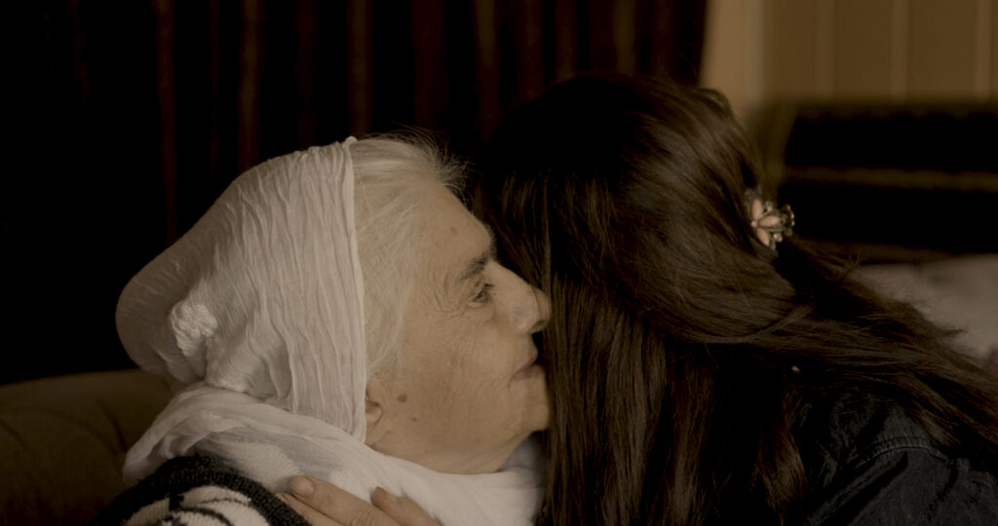
The_Cemetery_of_the_Nameless_hesam_yousefi

Key facts
Format | Documentary, Short film
Status | Completed
Original title | The Cemetery of the Nameless
Year | 2024
Running time | 24 min
Production countries / regions | Germany
Filming locations | Kurdistan
Original languages | Kurdish
Subtitles | German, English
Shooting format | Digital
Screening format | DCP, MP4 (H.264)
Aspect ratio | 1.85:1 (Flat)
Colour | Colour
Sound | Stereo, 5.1

Synopsis
The Cemetery of the Nameless is a documentary in the tradition of cinéma vérité, telling the story of women’s rights activists Bahar Munzir and Laveh Mohammad. They follow the case of Darya, a woman murdered by her own brother — a victim of femicide. Darya’s family chooses not to press charges and attempts to cover up the killing, hoping the murderer will be released from prison early.
The film makes invisible violence against women visible, revealing the many legal obstacles and hardships these women’s rights campaigners face within Iraq’s justice system, including in South Kurdistan. The court denies them and other female lawyers access to Darya’s case file. Bahar and Laveh do everything in their power to persuade the family of the femicide victim to bring the perpetrator to trial so that he might receive a life sentence. But the family forgives the murderer, and the court hands down a seven-year prison sentence for Darya’s killer. Under Iraqi law, he could be released early on amnesty terms.
At the same time, this 24-minute film takes viewers to anonymous cemeteries where thousands of women who fell victim to femicide lie buried. The Cemetery of the Nameless also offers glimpses into Bahar Munzir’s private life, showing how she and her colleagues fight against injustice.

Film stills
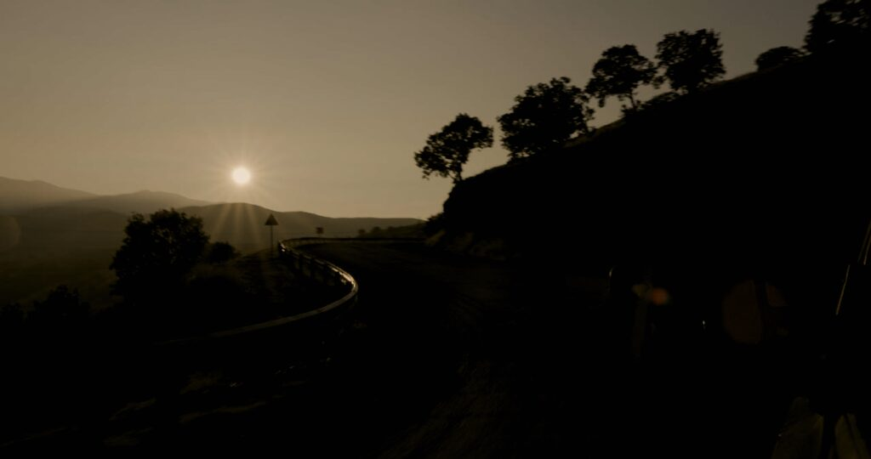
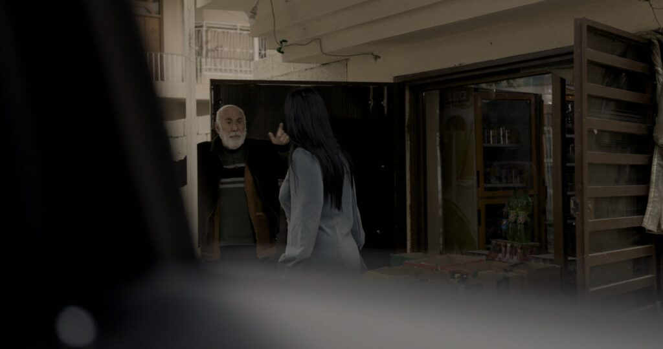
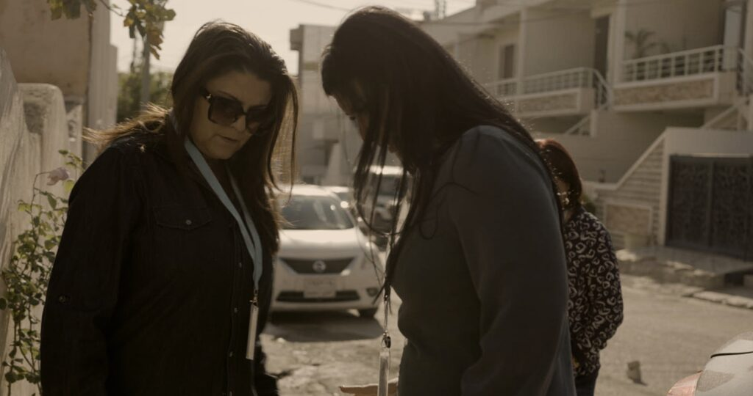

Awards
2024 Winner · Best Graduation Film · Der Hessische Film- und Kinopreis

Production & Funding
Production | Darmstadt University, Hesam Yousefi
Funded by | hessenfilm

Credits
Protagonist | Bahar Munzir, Shukriye Kurdi, Lava Mohammad
Director | Hesam Yousefi
Cinematography | Hesam Yousefi
Music | Firmesk Hafez, Dlzar Abedi
Sound designer | Sara Tavakoli
Editing | Hesam Yousefi
Producer | Hesam Yousefi

https://hesamyousefi.com/films/the-cemetery-of-the-nameless/

