The Illusion of Security
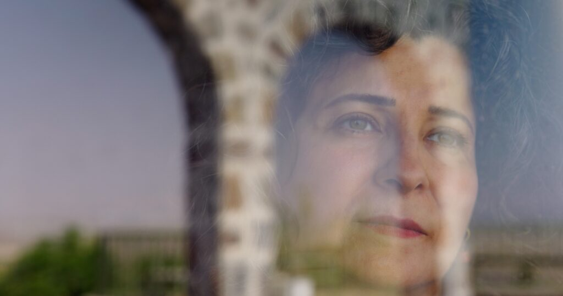

Key facts
Format | Documentary
Status | Completed
Original title | The Illusion of Security
Year | 2026
Running time | 61 min
Production countries / regions | Germany
Filming locations | Kurdistan
Original languages | Kurdish
Subtitles | German, English
Shooting format | Digital
Screening format | DCP, ProRes, MP4 (H.264)
Resolution | 4K DCI
Aspect ratio | 1.85:1 (Flat)
Colour | Colour
Sound | Stereo, 5.1

Synopsis
„The Illusion of Security“ is a poetic, observational documentary film about two women in southern Kurdistan (northern Iraq), who struggle daily for something that many appear to take for granted: security. In a region in which freedom can be life-threatening, Choman Hardi, professor and activist, and Avin Nasrin, independent journalist, confront the violence with courage, eduction and a belief in change.
The director Hesam Yousefi, who himself fled eastern Kurdistan, brings his own perspective into the narrative. His voice connects the women’s stories with a overriding existential question: what does security mean in a world that offers none?

Film stills
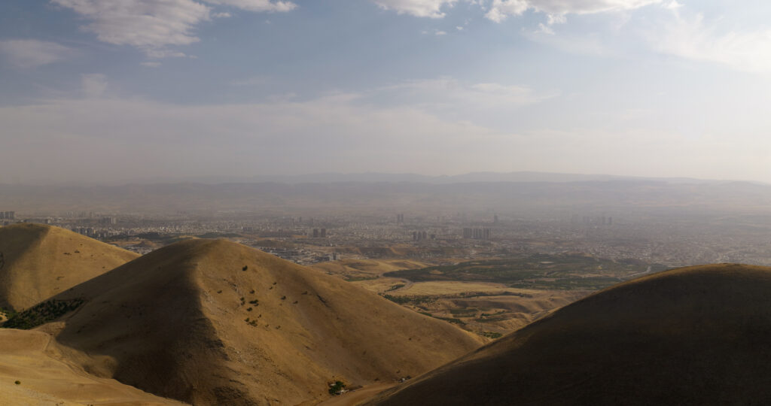
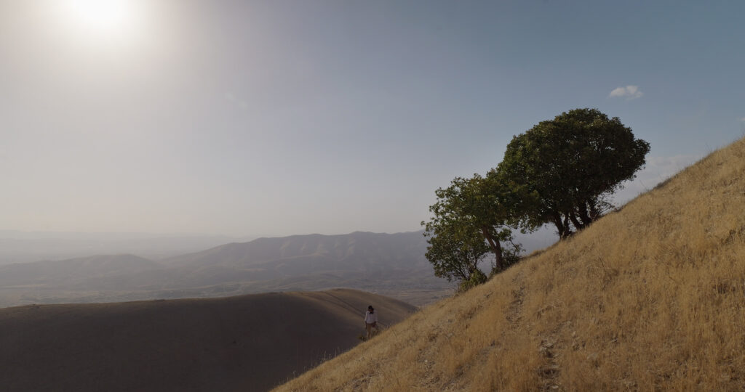
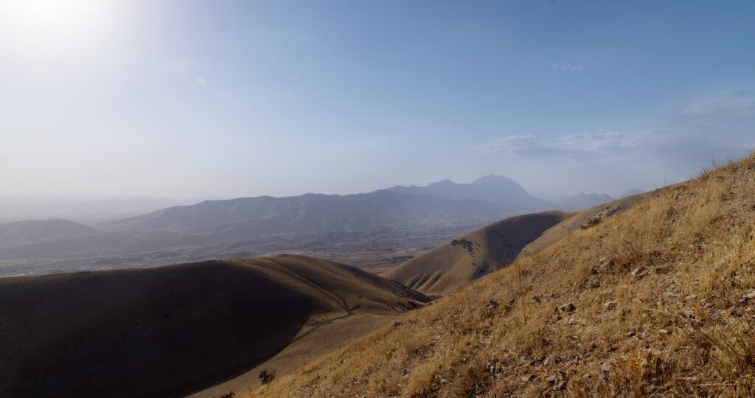

Production & Funding
Production | Academy of Media Arts Cologne, Hesam Yousefi

Credits
Protagonist | Choman Hardi, Avin Nasrin Hassan
Concept | Hesam Yousefi
Director | Hesam Yousefi
Sound designer | Sara Tavakoli, Max Galos
Audio Mix | Ralf Schipke
Color grading | Ewald Hentze
Editing | Hesam Yousefi
Editing and Dramaturgical Supervision | Rita Schwarze
Editing Supervision | Fani Schoinopoulou BFS, Christian Becker
Supervision | Prof. Oliver Schwabe, Prof. Phillipp Scheffner
Production Assistant | Firmesk Hafez
Producer | Hesam Yousefi
Translator | Irma Mečević
Project Office | Ursula Reber
Accounting | Kasia Renner
PR & Festivals | Ute Dilger

https://hesamyousefi.com/films/the-illusion-of-security/

